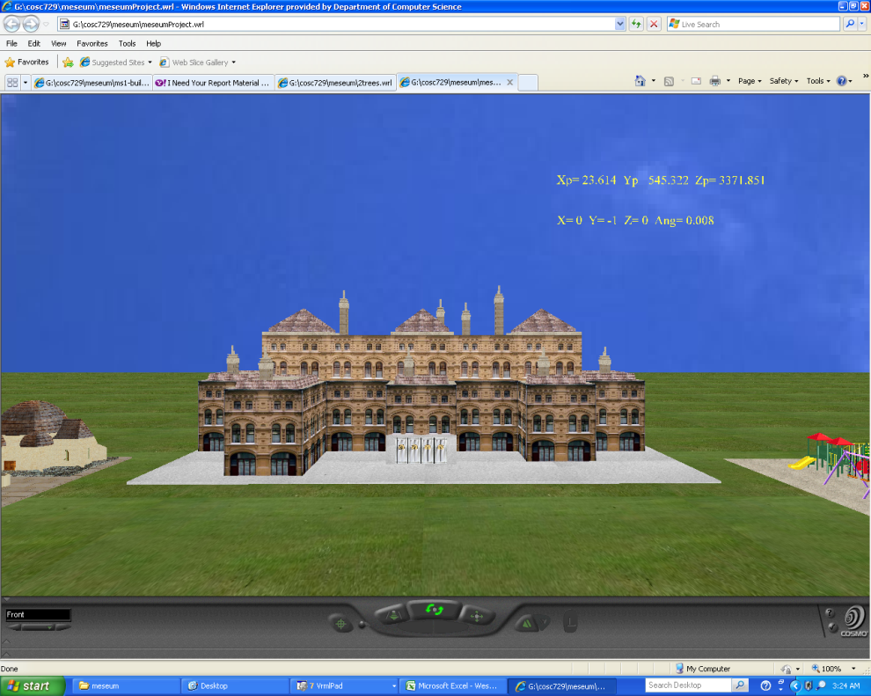

**Group Members**:

**Bette Donahue**

**Daryl Davis**

**Tyreek Edward**

**Emily Mudede**

**Project Report**

**COSC 729/490**

**Spring 2010**

***GOAL AND OBJECTIVES****:*

The goal of our project is to create a virtual children’s museum that gives users the opportunity to explore and play with various objects and games for their entertainment. The museum contains 6 main regions: an outdoor area (including a playground and a playhouse), the lobby, a kid’s room containing movie characters and objects, a maze, an obstacle course and a treasure hunting game. Additional objects may be added to the final project before its submission next week time permitting including a car racing game.

***LINKS/ TEXTURES/ SENSORS/ LIGHTS:***

The project used a variety of textures, lights, sensors, and lights to enhance the users experience as they wonder through the marvels of the children's museum. Below is a listing of such items for each component of the museum:

**Outside Area**:

* **Objects:** buildings
* **Images:** museum exterior
* **Textures:** see links below
* **Sensors:** Touch sensors and anchors
* **Links:** <http://www.greatbuildings.com>

**Lobby and Kid’s Room:**

* **Objects:** couches and airplane, statues: Patrick Star, Peter Griffem, Harry Potter’s Dobby
* **Images:** Monsters Inc. and Lion King
* **Textures:** see links below
* **Sensors:** Touch sensors, cylinder sensors and anchors
* **Lights:** Spot and point lights
* **Links:**

[**http://www.luciddreamexplorers.com/images/monsters_inc.jpg**](http://www.luciddreamexplorers.com/images/monsters_inc.jpg)

[**https://www.buddytv.com/battleimages/usr3385920/3385920_ce2d9c56-40a7-44e1-ab2a-767be1652ddc-circle-of-life---lion-king.jpg**](https://www.buddytv.com/battleimages/usr3385920/3385920_ce2d9c56-40a7-44e1-ab2a-767be1652ddc-circle-of-life---lion-king.jpg)

[**http://www.3dvalley.com/3d-models/household**](http://www.3dvalley.com/3d-models/household)

**Obstacle Course/Treasure Hunting Room:**

* **Textures:** 3ds Max 2009, <http://twistedphysics.typepad.com/cocktail_party_physics/images/butterfly.jpg>
* **Sensors:** Touch sensors, plane sensor, orientation and position interpolators and anchors
* **Lights:** Point and directional lights
* **Links:** sunflower, flower sphere, cube star and butterfly

[**http://www.musicandvirtualflowers.co.uk/virtualflower/index.html**](http://www.musicandvirtualflowers.co.uk/virtualflower/index.html) sunflower and moving object rooms

[**http://www.matryx.net/vrml/**](http://www.matryx.net/vrml/) butterfly

**Maze**:

* **Sensors:** Touch sensors, anchors, and proximity sensors
* **Lights:** Point and directional lights

***Software / Hardware Used:***

**Software:**

* 3DS Studio Max 2009
* VRMLPad 2.0
* MS Paint
* CosmoPlayer
* Windows XP

**Hardware:**

* Dell Precision T3400 Workstation
* Core 2 Quad Processor 2.4 GHz
* 8 GB Ram

***MODELING:***

**Outside Region:**

The outside region consists of the background, the main museum building, a playhouse and a play area. The playground has a swing set, multiple slides and a whirl around which all have sensors to provide animation. The playhouse area will have a fountain in its courtyard and both external and internal views. Different camera views of the exterior area will be available to allow the user to move quickly from one region to another. Touch sensors on the doors to both the museum and the playhouse will function as anchors to internal views for the buildings. See links for structures and images used.

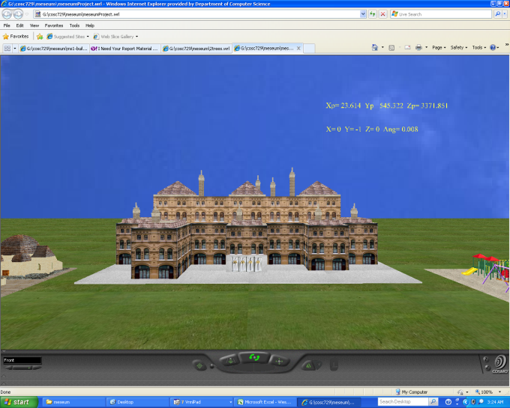

**Figure:** Outside region - museum external, playground and playhouse.

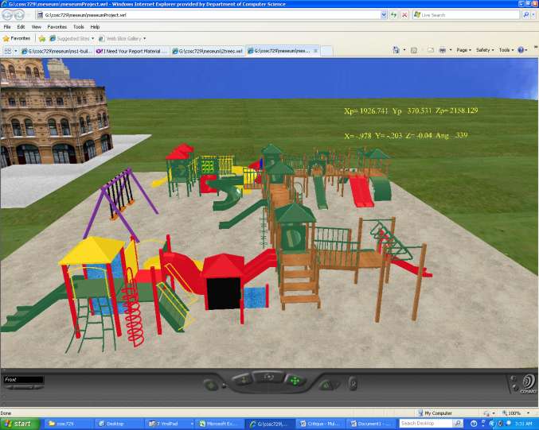

**Figure:** Playground - swing set, slides and whirl around.

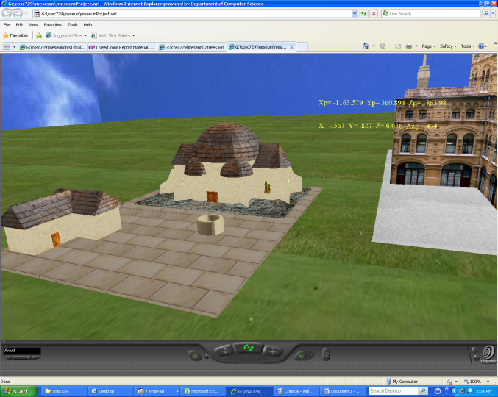**Figure:** Playhouse - both external and internal areas with fountain.

**Lobby:**

The lobby area will contain posters, sitting areas, a front desk a plane and statues. It will be the main connection to all the other rooms in the museum. Anchors will be placed on the various doors to enter the other rooms includes the kid’s room, the obstacle course, the treasure hunting game and maze. See links for structures and objects used.

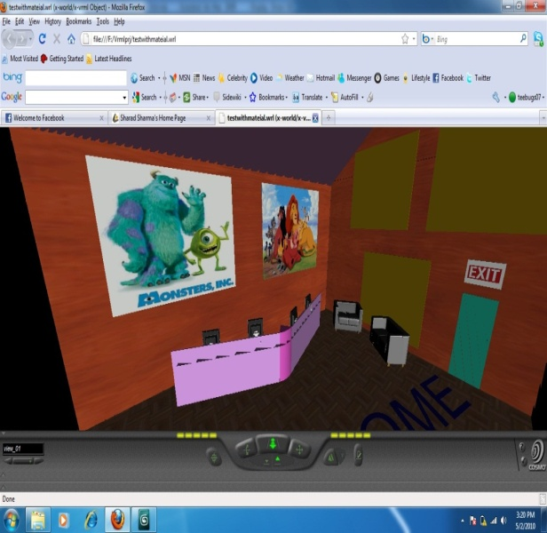**Figure:** Lobby - back wall. 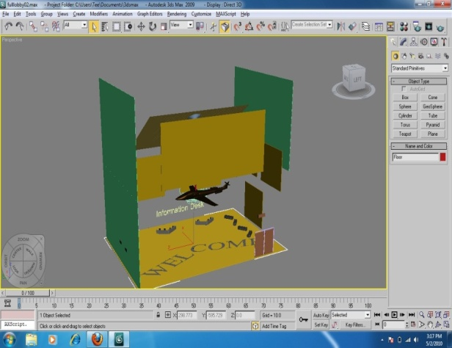**Figure:** Lobby - overall view

**Kids Room:**

This room will features different cartoon characters. You will be able to navigate throughout the room and interact with the pictures and characters in the room. You may be able to click them and get some information about them or even spin them around to get a better view of them. When buttons on the wall are touched the pictures on the wall will change. There will be a cylinder sensor with the statues that will let the avatar rotate the statues for a 360 view.

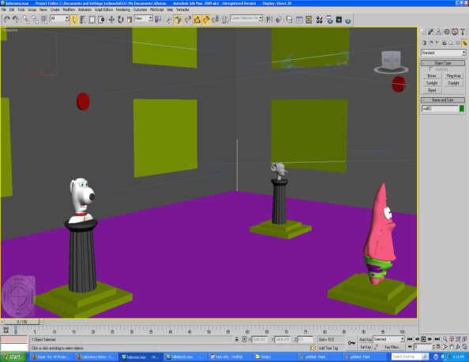**Figure:** Kids Room - Statues

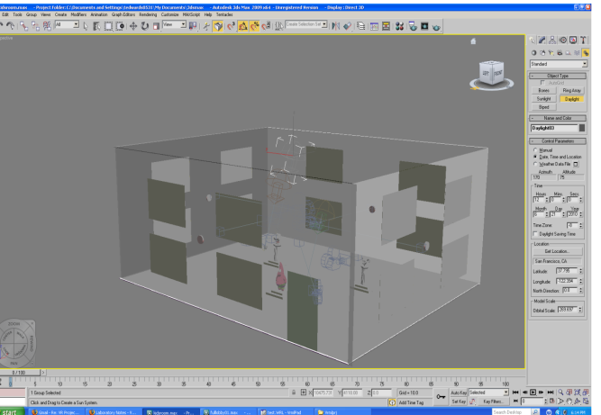**Figure:** Kids Room - Overall View

**Obstacle Room:**

The obstacle room was designed to challenge the users to navigate the various obstacles to explore the room without falling. The obstacles being navigated include moving bridge pieces, spinning rooms and traps from which the user cannot escape. The user will be given the option of retrying the obstacle course as many times as he wishes or he can leave this room to enter the treasure game or the lobby.

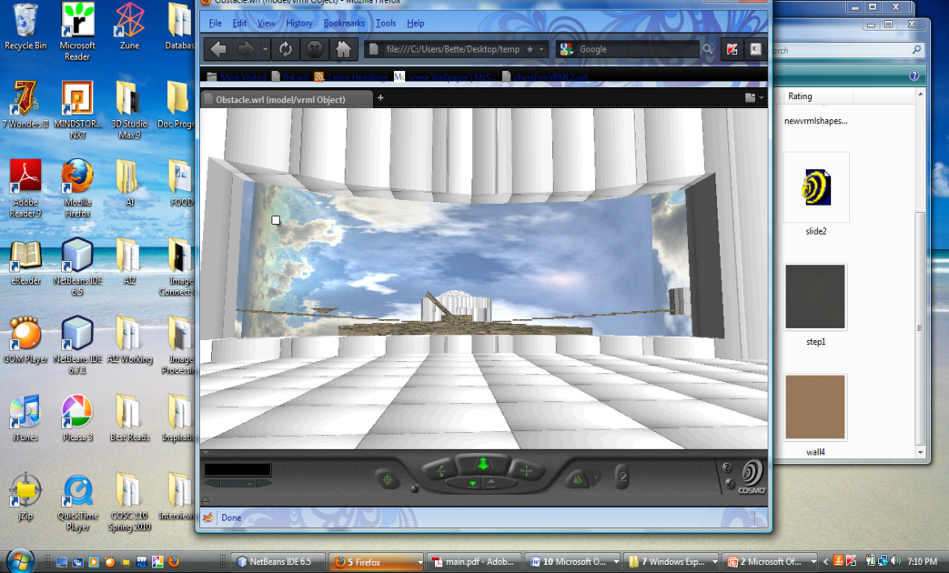**Figure:** Obstacle Course - Entrance, floating path, and rotating steps, rooms and sphere.

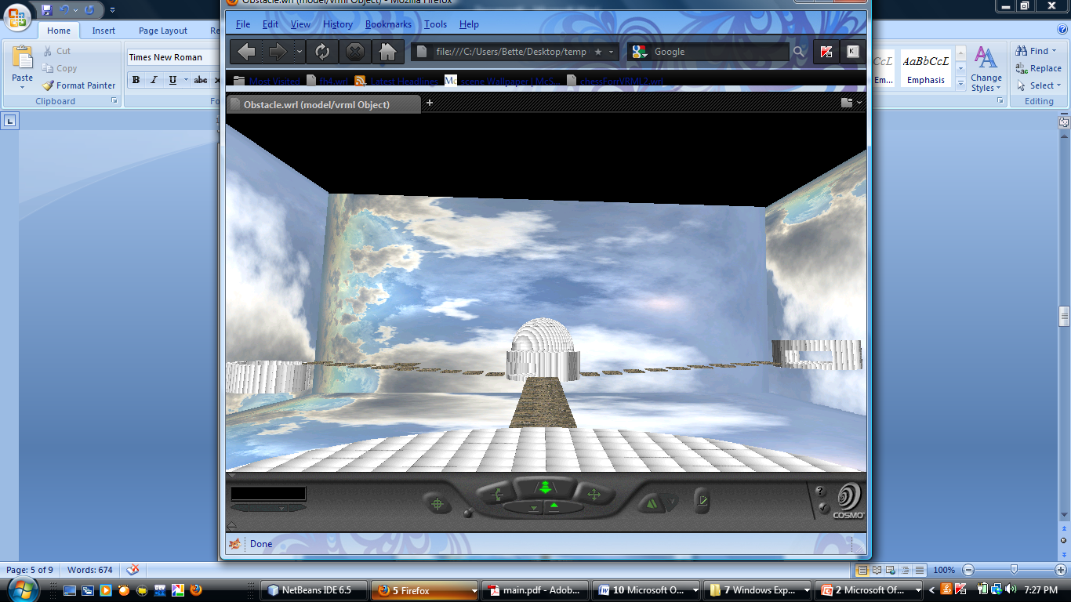**Figure:** Obstacle Course - Overall view.

**Treasure Hunting Game**:

The treasure hunt game allows the user to explore different areas in this room using the different doors on the staircase. The user can also exit this region of the room by using the doorways in the spinning wall.

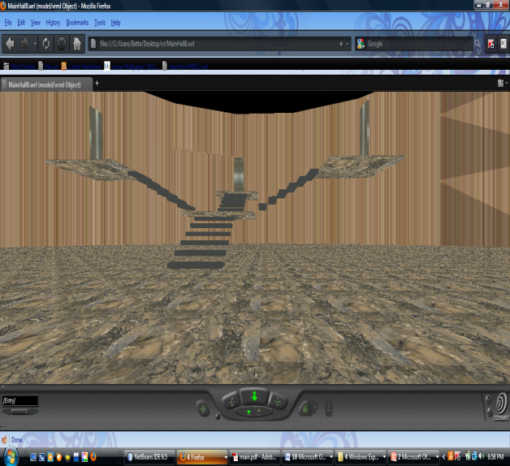**Figure:** Treasure Hunting Game - Stairway

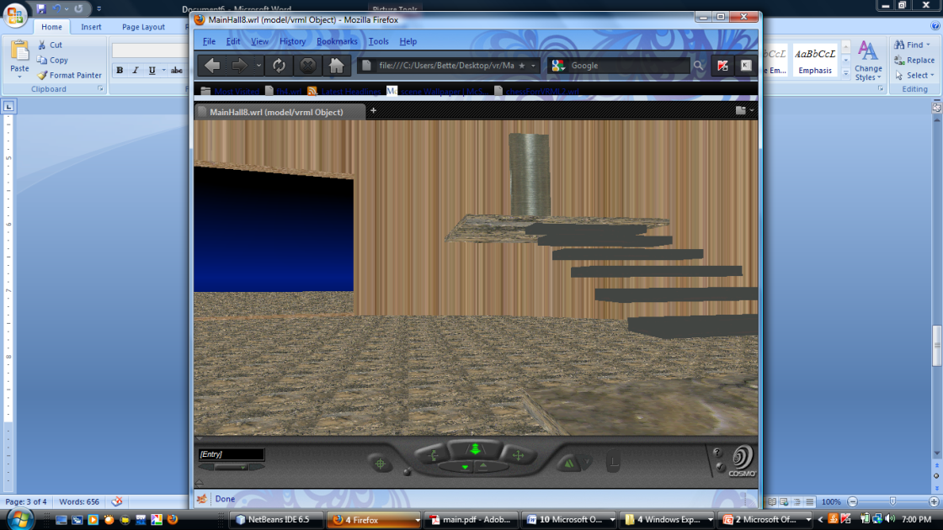

**Figure:** Treasure Hunting Game - Stairway and Doorway

**3D Maze**:

The 3D maze is comprised of a series of strategically placed boxes that create the illusion of hallways. The user must navigate the numerous hallways in order to find the hidden key that unlocks the doors to get back to the museum. The doors will only function after the key has been located and collected.

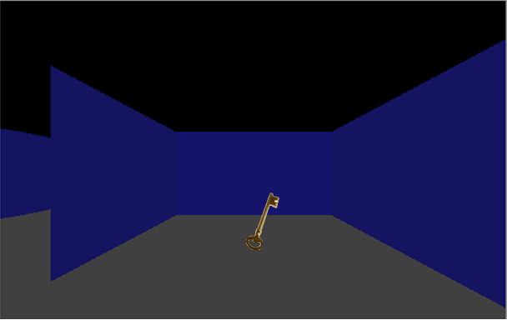**Figure:** Hidden Key

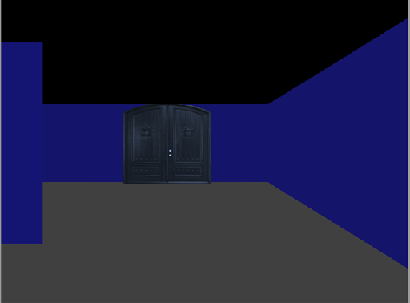**Figure:** Hidden Door

* **Lobby/Kid’s Room:** A major problem was the placement of objects in the rooms. Misplacement caused some zebra print on objects.
* **Obstacle Course/Treasure Hunting Game:** I had a problem making by spinning spheres and the spinning walls solid. Users could sometimes get caught between the two walls of the objects.
* **Maze:** More hallways can be added to the maze to make it more complex. Additionally, changing the anchor on the exit door to link to another maze level would add to the complexity of the maze.

***PROBLEMS /FUTURE IMPROVEMENTS:***